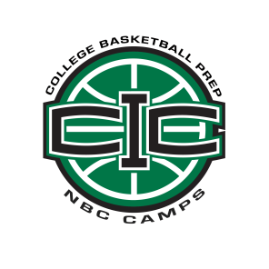
CIC College Prep Camp Application
Please email completed form to cic@nbccamps.com

Name:
First Last

Address:
City State Country

School Name:

Grade Level (as of 2014-2015 school year): 9 10 11 12 Height: ft. in.

Position in basketball: Point Guard Shooting Guard Small Forward Power Forward Center

How many years have you attended CIC?

How many years have you attended NBC Camps?

What level of basketball did you participate in last season? ( i.e. Jr. High, High School JV, Varsity, etc.)

What was your role on the team? (i.e. Captain, Starter, 6th man, etc.)

What were your approximate season averages in:
Points
Rebounds
Assists
Other

What are you involved in outside of basketball?

Why do you want to go to CIC?

Why do you think we should accept you to attend this camp?

